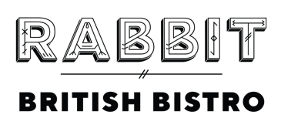

We use all things wild, foraged & locally grown, including sustainable livestock from the Gladwin’s family farm in Sussex & by-catch specials from nearby coastlines. We call this “Local & Wild”.
LOCAL & WILD MENU
52.0 | +38.0 for wine pairing
Snacks
Mushroom Marmite Éclair, Egg Confit, Cornichon
Goats Cheese Mousse, Tartlet, Sussex Honey
Nutty Wild, NV, Nutbourne Vineyards, Sussex

Sea
Plaice Goujons, Tartare Sauce
Sussex Reserve, Nutbourne Vineyards, Sussex, 2023

Soil
Grilled Red Gem Lettuce, Ceasar Dressing, English Pecorino
Barrel Fermented Chardonnay, Nutbourne Vineyards, Sussex, 2023

Farm
Braised Lamb Chips, House Harissa
Baccolo Appassimento Rosso, Veneto, 2022

Grass
Dry Aged Lyons Hill Farm Beef Sirloin, Chimichurri, Jus
Altura 350, Dom P.Sichel, Grenache, Syrah, Carignan, 2019

Sweet
Elderflower Set Cream, Summer Berries
Coteaux De Layon, Château Soucherie, France, 2020

